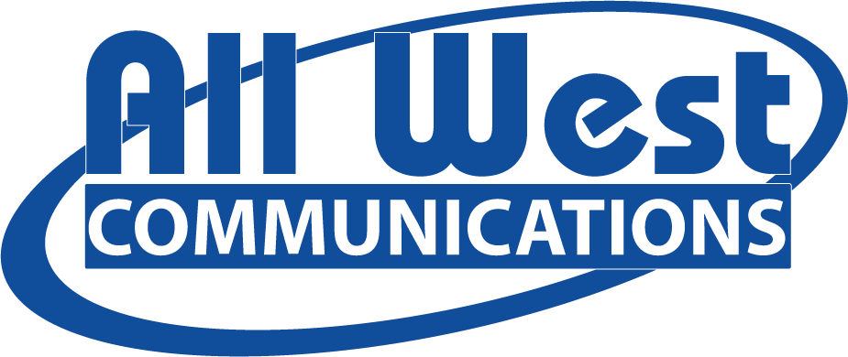

All West Communications is a leader in providing internet, TV streaming and phone service and is growing rapidly! As a Field Sales Representative at All West Communications, you will have the responsibility of driving sales and acquiring new customers for our products and services. You will play a vital role in expanding our customer base and promoting our brand within the community.

**Responsibilities:**

* Approach potential customers door-to-door to introduce and promote All West’s internet, video and voice services.
* Listen attentively to customer needs, address inquiries, and tailor sales pitches to match their needs.
* Utilize selling techniques to overcome objections and close sales on the spot.
* Own the sales process from start to finish.
* Meet or exceed sales targets and performance metrics set by the company.
* Build and maintain a pipeline of leads through strategic prospecting and networking efforts.

**Qualifications:**

* Previous experience in direct sales, preferably in the telecommunications, internet, or related industry.
* Excellent interpersonal and communication skills with the ability to engage and build rapport with diverse customers.
* Strong negotiation and persuasion abilities, with a confident and outgoing demeanor.
* Self-motivated and results-oriented, with a drive to succeed in a fast-paced, target-driven environment.
* Ability to work independently and manage time effectively to maximize productivity.
* Comfortable working outdoors and walking for extended periods in various weather conditions.
* Basic computer skills for order processing and reporting purposes.
* Valid driver's license and access to a reliable vehicle for daily travel within assigned territories.
* Tuesday-Saturday (Tuesday-Friday: 11 am – 7 pm OR 12 pm – 8 pm, Saturday: 10 am – 6 pm)

**Compensation**

$18 base + uncapped commission

Mileage reimbursement